**CHAPTER 3: REQUIREMENTS, ANALYSIS, AND DESIGN**

**3.1 OVERVIEW**

This chapter presents the systematic approach employed to gather, analyse, and transform user requirements into a comprehensive system design for the Hajj Guide System. The requirements engineering process followed established software development methodologies whilst incorporating specific considerations for Islamic educational technology and Nigerian user contexts. The chapter documents the complete journey from initial requirement identification through final system architecture specification.

The requirements analysis phase involved extensive stakeholder consultation including Islamic scholars, previous Hajj pilgrims, technology users, and educational technology experts. This multi-stakeholder approach ensured comprehensive understanding of both religious authenticity requirements and practical usability needs. The methodology combined traditional software engineering techniques with culturally appropriate research methods suitable for Islamic educational contexts.

The system design process translated identified requirements into technical specifications that support the four primary project objectives: sequential learning implementation, interactive multimedia integration, functional utility development, and religious authenticity preservation. Each design component received careful consideration to ensure alignment with both technological capabilities and Islamic educational principles.

The proposed web-based system architecture leverages modern Next.js framework capabilities to deliver comprehensive Hajj guidance through progressive learning modules, interactive demonstrations, and practical utility components. The design prioritizes user experience whilst maintaining strict adherence to Islamic pedagogical traditions and scholarly validation requirements.

**3.2 PROPOSED MODEL**

The Hajj Guide System employs a Sequential Progressive Learning Model specifically designed for complex multi-day religious ceremonies requiring precise chronological understanding and practical application skills. This model combines traditional Islamic teaching methods with modern web-based learning tools to make a single platform that helps with all aspects of Hajj preparation and guidance.

The main model structure is based on the real Hajj timeline, which runs from the 8th to the 13th days of Dhul-Hijjah. Each day is a separate learning module with its own rituals, educational content, and hands-on activities. Users must show that they understand each module before they can move on to the next one. This makes sure that knowledge is built up in a systematic way and that users don't get too much information at once.

Each learning module contains four important parts that are in line with Islamic educational traditions. The instructional component presents ritual procedures through multimedia demonstrations and scholarly explanations. The practice component provides interactive simulations and utility tools for ritual rehearsal. The assessment component evaluates understanding through contextually appropriate questioning techniques. The reflection component encourages spiritual contemplation and personal preparation for actual pilgrimage performance.

The proposed model addresses identified deficiencies in current Hajj guidance applications by employing genuine sequential progression instead of random-access information retrieval. This method is in line with traditional Islamic teaching methods, but it also uses modern web technologies to make learning more accessible and interesting.

**3.3 Adopted Methodology**

This project adopts the **Agile Software Development Methodology**, an iterative and incremental approach that emphasizes flexibility, user collaboration, and continuous delivery of functional software. Agile is guided by principles such as prioritizing working software, involving users in development, and responding effectively to changing requirements. The Hajj Guide System is interactive and feature-rich, integrating ritual simulations, Tawaf counters, Dua playback, and Hadith content. These features require progressive development and frequent evaluation to ensure both usability and religious accuracy. Agile is therefore appropriate as it allows incremental delivery of modules and accommodates evolving requirements, with development carried out in iterative sprints that deliver usable components at each stage

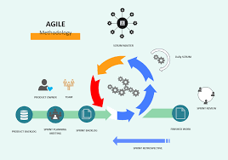

*Figure 3.1: Agile Methodology*

**3.3.1 Method 1: Semi-Structured Interviews**

The interview methodology employed culturally sensitive approaches designed to elicit comprehensive information about Hajj preparation experiences and digital guidance needs. Interview participants included 15 individuals representing diverse stakeholder categories: five previous Hajj pilgrims with varying experience levels, three Islamic scholars specializing in Hajj jurisprudence, four technology users representing different demographic groups, and three educational technology professionals.

Interview questions explored current preparation methods, challenges encountered during actual pilgrimage performance, preferences for digital guidance features, and cultural considerations affecting technology acceptance. The semi-structured format allowed for flexible questioning that accommodated cultural communication styles whilst ensuring systematic data collection.

Interviews were conducted in participants' preferred languages (English, Fulani, or Hausa) to ensure clear communication and authentic responses. Each interview lasted between 25-30 minutes, with audio recording permission requested respectfully and transcription completed within 48 hours to maintain accuracy.

The interview process revealed significant insights regarding sequential learning preferences, multimedia content requirements, utility component priorities, and religious authenticity expectations. Participants consistently emphasized the importance of scholarly validation and cultural appropriateness in digital Islamic educational platforms.

Data analysis employed thematic coding techniques to identify recurring patterns and requirements across different participant categories. The analysis revealed convergent themes regarding sequential progression needs, interactive engagement preferences, and practical utility requirements that informed subsequent system design decisions.

**3.3.2 Method 2: Systematic Observation**

The observation methodology examined current digital Hajj guidance usage patterns and identified usability challenges in existing applications. Observation sessions involved 12 participants using three popular Hajj guidance applications whilst completing specific preparation tasks under controlled conditions.

Observation protocols documented user interaction patterns, navigation difficulties, content comprehension challenges, and feature utilisation rates. Sessions were conducted in natural learning environments to ensure authentic usage behaviour whilst maintaining systematic data collection standards.

Participants represented diverse technological literacy levels and demographic backgrounds to ensure comprehensive understanding of usability requirements across the target user population. Each observation session lasted 60 minutes, with detailed behaviour logging and post-session debriefing interviews.

The observation process revealed critical usability issues in existing applications including navigation confusion, content accessibility problems, and insufficient interactive guidance. Participants frequently expressed frustration with non-sequential information organization and lack of comprehensive utility integration.

Quantitative metrics collected during observation included task completion rates, error frequencies, navigation path analyses, and feature engagement levels. These metrics provided objective evidence supporting qualitative findings regarding user experience improvements needed in digital Hajj guidance systems.

**3.4 Tools and Techniques**

The development of the Hajj Guide System required a combination of frameworks, databases, design tools, testing platforms, and deployment services. Each tool and technology was selected based on its suitability for building an interactive, scalable, and educational platform that supports Islamic content presentation. The table below provides a summary of the key tools and technologies employed in the project alongside their specific purposes.

**Table 3.1: Tools/Techniques**

|  |  |  |
| --- | --- | --- |
| Tools/Techniques | Category | Purpose in Hajj Guide System |
| Next.js 14.0 | Framework | Enables fast, full-stack web app with smooth navigations for ritual and Guide |
| MongoDB | Database | Stores Multilingual Duas, Hadith references and overall user data and progress. |
| React + Tailwind CSS | Frontend | Build responsive, user-friendly for pilgrims on all devices |
| HTML5, Web Audio, CSS Animation | Multimedia | To deliver ritual demonstration videos, Qur’anic recitation audio, and animated visual guides for pilgrims such as Tawaf counter and Jamarat stoning |
| Git & GitHub | Version Control | Supports collaboration, code tracking, and content validation. |
| Manual Testing | Testing | Ensures correct functionality and Islamic accuracy of features. |
| Vercel | Deployment | Hosts the system globally with fast and reliable access for pilgrims |

**3.5 ETHICAL CONSIDERATIONS**

The project development process incorporated comprehensive ethical frameworks addressing both technological development standards and Islamic ethical principles. Ethical considerations encompassed participant welfare, religious sensitivity, cultural appropriateness, and scholarly responsibility throughout all project phases.

Participant consent procedures followed university research ethics guidelines whilst incorporating Islamic consultation traditions. All interview and observation participants received detailed information about project purposes, data usage intentions, and confidentiality protections. Consent forms were provided in participants' preferred languages with clear withdrawal options.

Religious content accuracy represented a critical ethical responsibility requiring systematic scholarly consultation and validation processes. All ritual guidance content received verification from qualified Islamic scholars before implementation, with ongoing review mechanisms for content accuracy maintenance.

Cultural sensitivity protocols ensured respectful presentation of Islamic practices and beliefs throughout the system design process. Design decisions prioritised authentic representation over technological novelty, avoiding approaches that might trivialise or misrepresent sacred religious practices.

Data privacy protection employed industry-standard security measures for user information storage and transmission. The system design minimized personal data collection requirements whilst providing necessary functionality for progress tracking and personalized guidance.

Accessibility considerations ensured inclusive design approaches that accommodated diverse user capabilities and technological access levels. The ethical framework recognized technology access as an equity issue requiring systematic attention to inclusive design principles.

Intellectual property considerations respected Islamic scholarly traditions whilst acknowledging contemporary copyright requirements. All Islamic texts and scholarly quotations received appropriate attribution with permission obtained for copyrighted materials where required.

**3.6 REQUIREMENT ANALYSIS**

In the development of the Hajj Guide System, the requirement analysis process combined information gathered through interviews, observations, and a literature research to identify the needs of all stakeholders. The research distinguished between necessary needs, which are critical for system success, and desirable features, which improve user experience without compromising core functioning.

**3.6.1 Requirements for Educational Content**  
  
i. A list of the steps for the Hajj rituals.  
ii. Support for multimedia, such as text, pictures, sound, and animations.  
iii. Academic confirmation of religious veracity.  
iv. Support for more than one language (Arabic and English).  
  
**3.6.2 Requirements for Interactive Functionality**  
  
i. Keeping track of and watching how users are doing.  
ii. Tests and quizzes that ask questions in a way that is culturally appropriate.  
iii. Personalization options that let you change the way you learn.  
 **3.6.3 Requirements for the Utility Component**  
  
i. A Tawaf counter to keep track of circumambulations.  
ii. A tracker for the stoning of Jamarat.  
iii. The system has a built-in prayer time calculator.  
  
**3.6.4 Requirements for Cultural Appropriateness**  
  
i. Islamic principles of design for beauty.  
ii. Presenting content that is sensitive to gender.  
iii. Academic approval to make sure it's okay.  
iv. Interfaces that show how to interact with respect for other cultures.  
  
**3.6.5 Requirements for Technology**  
  
i. The system works quickly and smoothly.  
ii. Works with all browsers and devices.  
iii. Safe handling of user information.

**Table 3.2: Hardware Requirements**

|  |  |
| --- | --- |
| Components | Requirement |
| Users(Pilgrims) | Smartphone or PC  - Minimum 2 GB RAM  - Stable Internet (3G/4G or Wi-Fi) |
| Servers(Hosting) | - Quad-core Processor  - 8 GB RAM  - At least 250 GB Storage  - Reliable High-speed Internet |

**Table 3.3: Software Requirement**

|  |  |
| --- | --- |
| Components | Specifications |
| Users(Pilgrims) | -Supported OS: Android 8.0+, iOS 12.0+, Windows 10+ - Browser: Chrome, Firefox, Safari, or Edge  - Device: Smartphone, Tablet, or PC |
| Server(Hosting/Development) | - OS: Windows  - Frontend/Framework: React / Next.js  - Database: MongoDB  - IDE: Visual Studio Code(Vs Code) |

**3.7 REQUIREMENTS SPECIFICATIONS**

**3.7.1 Functional Requirement Specifications**

The functional requirements define specific behaviours and capabilities that the Hajj Guide System must demonstrate to achieve project objectives successfully. These requirements specify measurable functionality that users can observe and interact with directly.

**Table 3.4: Functional Requirement**

|  |  |  |
| --- | --- | --- |
| Requirement No. | Description | Type |
| FR-01 | The system shall allow users to sign up for an account. | Functional |
| FR-02 | The system shall allow users to log in with valid credentials | Functional |
| FR-03 | The system shall allow users to access study materials in sequential order. | Functional |
| FR-04 | The system shall administer quizzes after each module to measure user progress. | Functional |
| FR-05 | The system shall track and store user progress persistently across sessions. | Functional |
| FR-06 | The system shall detect user sessions and serve resources accordingly. | Functional |
| FR-07 | The system shall provide feedback assessment immediately after quiz completion | Functional |
| FR-08 | The system shall provide role-based access, allowing different permissions for pilgrims, scholars, and admins. | Functional |
| FR-09 | The system shall provide a Tawaf counter, Jamarat tracker, and prayer time calculator. | Functional |
| FR-10 | The system shall provide assessment feedback immediately after quiz completion. | Functional |

**3.7.2 Non-Functional Requirement Specifications**

Non-functional requirements establish quality attributes and performance standards that the system must maintain whilst delivering functional capabilities. These requirements ensure system usability, reliability, and appropriateness for the target user environment.

**Table 3.5s: Non-Functional Requirement**

|  |  |  |
| --- | --- | --- |
| Requirement No. | Description | Type |
| NFR-01 | The system shall be available 24/7 except during scheduled maintenance | Availability |
| NFR-02 | The system shall maintain at least 99.5% uptime during Hajj season. | Reliability |
| NFR-03 | The system shall load standard content in under 3 seconds. | Performance |
| NFR-04 | The system shall load multimedia-rich content in under 8 seconds. | Performance |
| NFR-05 | The system shall support at least 1000 concurrent users without performance degradation. | Scalability |
| NFR-06 | The system shall be compatible with major browsers (Chrome, Firefox, Safari, Edge) released within the last 3 years. | Compatibility |
| NFR-07 | The system shall be responsive and function across devices with screen sizes from 320px to 1920px. | Usability |
| NFR-08 | The system shall encrypt all user interactions and store personal data securely. | Security |
| NFR-09 | The system shall provide clear visual feedback for user actions and system errors. | Usability |
| NFR-10 | The system shall comply with Islamic design principles and present content respectfully. | Cultural Appropriateness |

**3.8 SYSTEM DESIGN**

**3.8.1 Application Architecture**

*Figure 3.2: Application Architecture*

**3.8.2 Use Case Diagram**

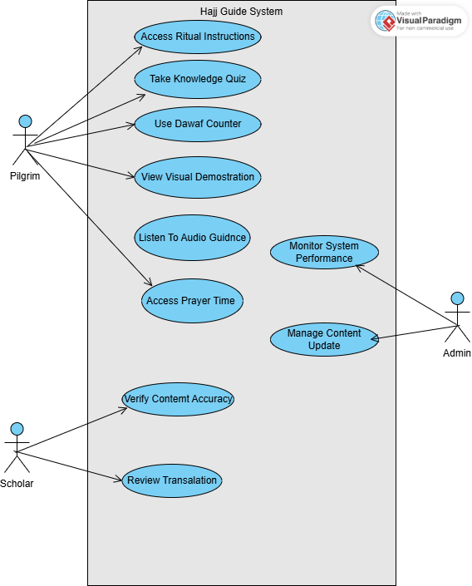

*Figure 3.3: Use Case Diagram*

**3.8.3 Data Design**

*Figure 3.4: Data Design Structure*

**3.8.4 Activity Diagrams**

*Figure 3.5: Activity Diagram*

**3.8.5 Dataflow Diagram**

*Figure 3.6: Dataflow Diagram*

**3.8.6 Control Flow Diagram**

*Figure 3.7: ControlFlow Diagram*

**3.8.7 Entity-Relationship Diagram (ERD)**

*Figure 3.8: Entity-Relationship Diagram (ERD)*

**3.8.8 User Interface Design**

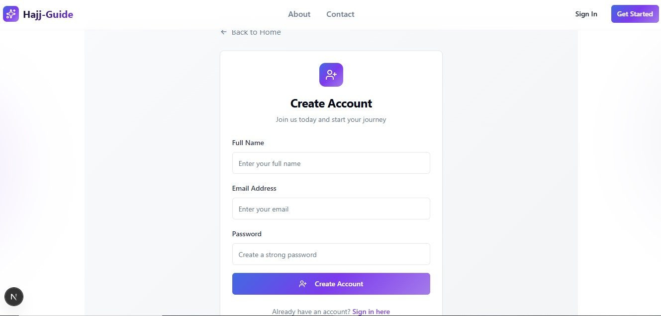

*Figure 3.9.1: User Interface Design –Signup page*

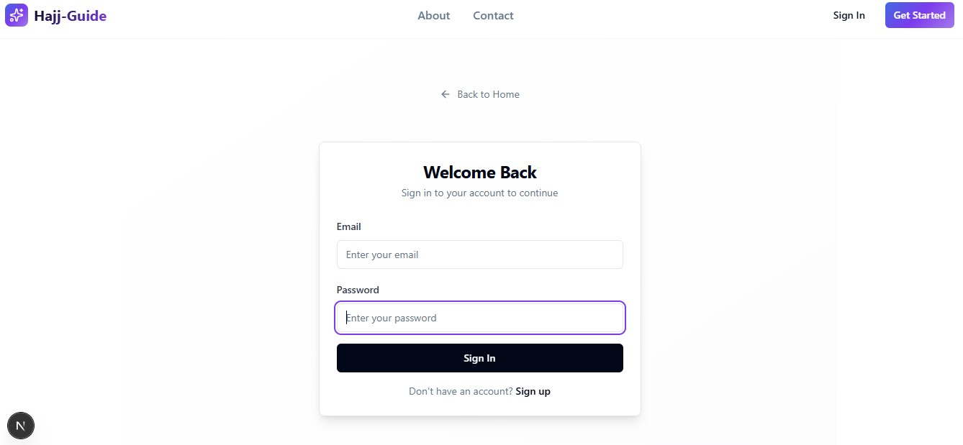

*Figure 3.9.2: User Interface Design –login page*

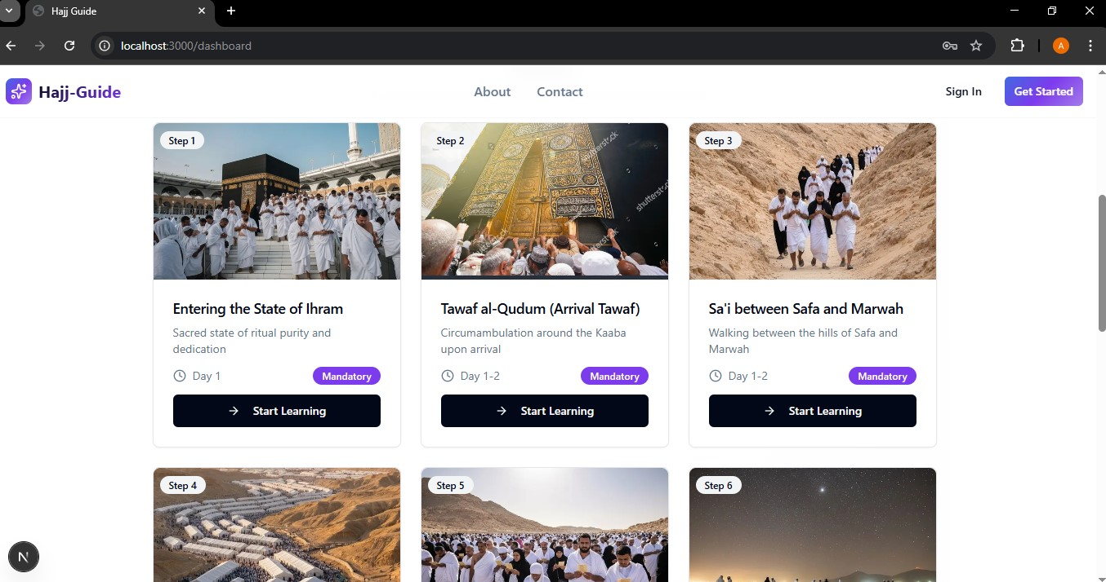

*Figure 3.9.3: User Interface Design –user dashboard page*

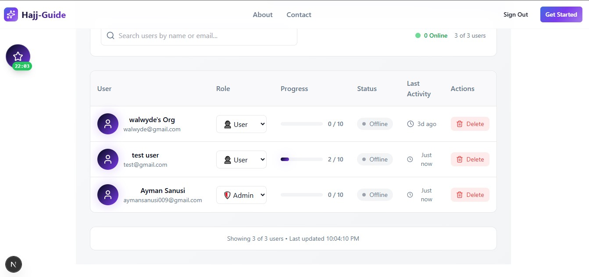

*Figure 3.9.4: User Interface Design –Admin Dashboard page*

**3.9 SUMMARY**

Chapter 3 presented comprehensive requirements analysis and system design for the Hajj Guide System, documenting the systematic approach employed to translate user needs into technical specifications supporting effective Islamic educational technology implementation. The methodology combined traditional software engineering approaches with culturally appropriate research techniques ensuring authentic community engagement throughout the requirements gathering process.

The proposed Sequential Progressive Learning Model addresses identified gaps in existing Hajj guidance applications by implementing true chronological progression through educational content whilst maintaining Islamic pedagogical traditions. The model supports both educational objectives and practical preparation requirements through integrated utility components and assessment mechanisms.

Requirements specifications established clear functional and non-functional criteria ensuring system success whilst maintaining cultural appropriateness and religious authenticity throughout implementation. The systematic approach to requirement gathering revealed convergent needs across different stakeholder categories whilst identifying specific priorities for different user groups.

System design documentation provides comprehensive technical specifications supporting effective development and implementation processes. The three-tier architecture ensures scalable performance whilst accommodating the specific requirements of Islamic educational content and diverse user environments.

The complete requirements analysis and design process established solid foundations for system implementation whilst ensuring alignment with project objectives and stakeholder expectations. The systematic approach supports both immediate development needs and future enhancement opportunities through modular architecture and comprehensive documentation.